**Battleship (Group)**

**Tsz Kwan**

no socket

Serialization: PlayerInfo.java

Regular expression: RegExCheck.java

Query: PlayerInfoQueries.java

SQL table: 209.129.8.4

Entity table: battleship_entity_user, battleship_entity_login

XRef table: battleship_xref_player_login

Enum table: battleship_enum_genderSplash Screen: vm options: -splash:src/proj1/loading.gif

Thread: splash screen: Battleship_GUI.java line 37

save function:

JFrame_Battleship.java line 1297, 1249

load function:

JFrame_Battleship.java line 1359, 1312, 1264

reset function:

JFrame_Battleship.java line 1372

File IO:

all save and load functions

**screenshot:**

**splash screen:**

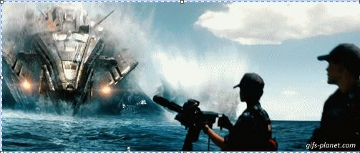

**start panel**

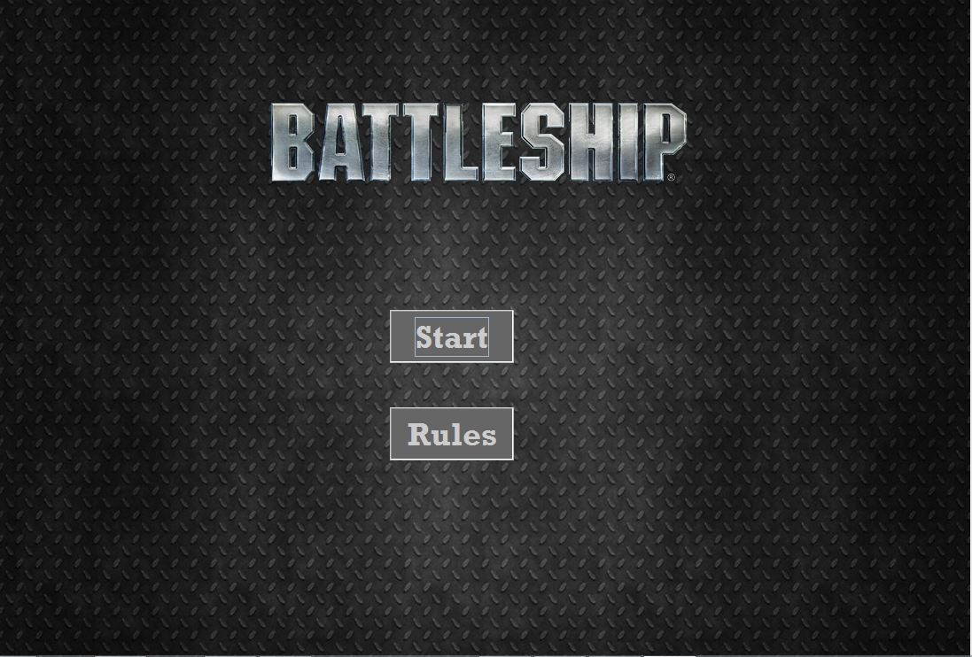

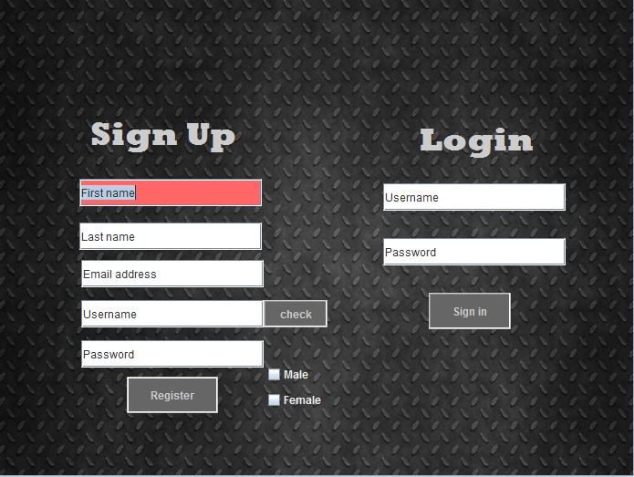**After Start, Login/ Register panel**

Has RegExCheck in each text field. After focus lost, the background of the text field turn green if valid, red if invalid.

Check button checks the Username with database to make sure the username is unique. Register button add the data to the database.

After press sign in and check with database, the prog will try to load the previous game if there is any. Otherwise, it will make a new game.

**Game Panel**

**New Game screenshot:**

Player only allows to place the ships by typing in the textfield

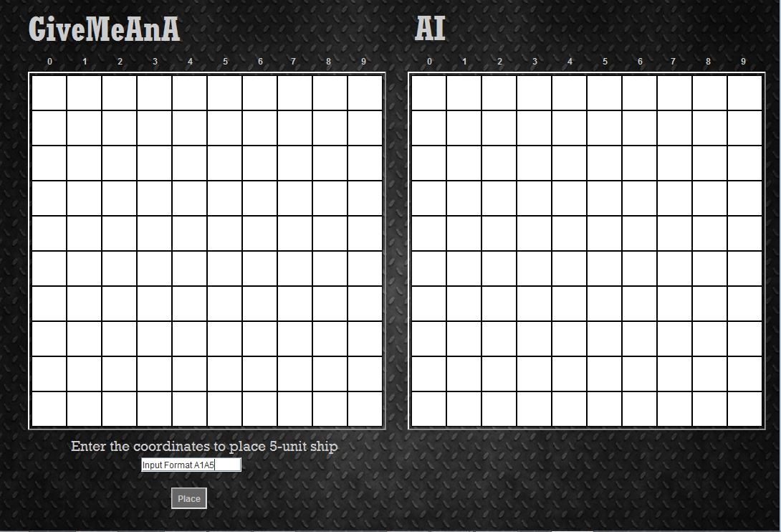

Fire Screenshot: yellow circle means miss, and red cross means hit. Player can either press the ai table or enter the coordinates to fire. Auto save each turn player fire.

